DIS-ME-Anatolia-Spade-shaped Female Figure

Spade-shaped schematic female figure, Early Bronze Age I, ca. 3000–2800 BCE, Anatolia, Limestone

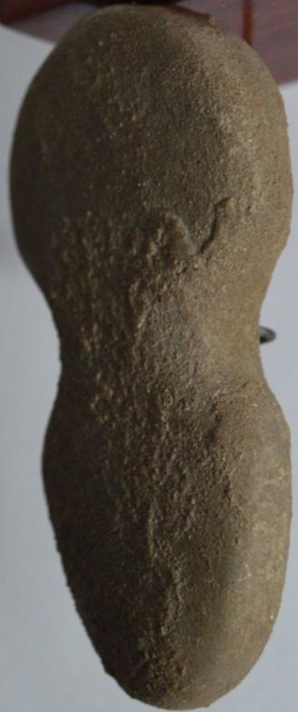 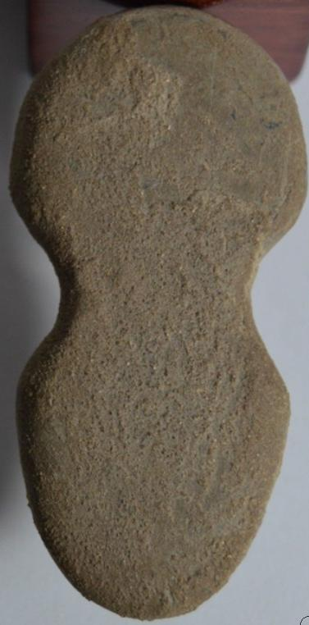 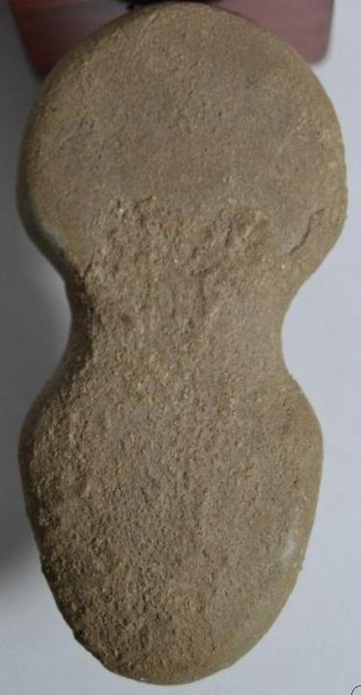

Formal Label: Anatolia, Spade-shaped schematic female figure, Early Bronze Age I, ca. 3000–2800 BCE, Limestone

Accession Number: GN778.32.A1

Date or Time Horizon: ca. 3000–2800 BCE

Geographical Area: Anatolia

Cultural Affiliation: Early Bronze Age I

Media: Limestone, crack professionally restored

Dimensions: 7.1 cm

Weight:

Provenance: Belgian Collection 1980; viajero-en-el-tiempo 1981-2016, Atlantika 2016

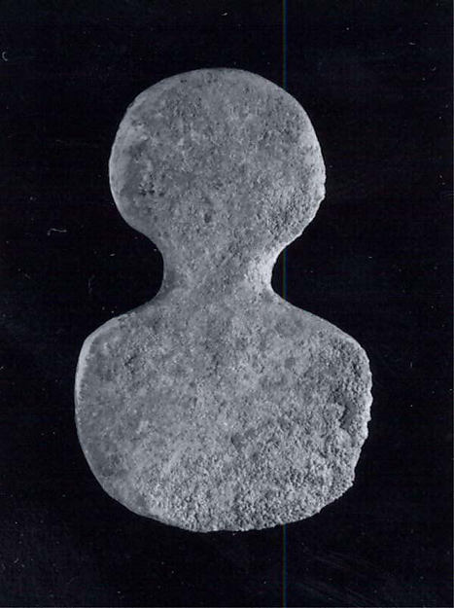

Formal Label: Spade-shaped schematic female figure

Accession Number: 67.183.6

Date or Time Horizon: ca. 3000–2800 BCE

Geographical Area: Anatolia

Cultural Affiliation: Early Bronze Age I

Media: Limestone.

Dimensions: 0.24 x 1.34 x 2.24 in. (0.61 x 3.4 x 5.69 cm)

Weight:

Provenance: Rogers Fund, 1967; Acquired by the Metropolitan Museum in 1967, purchased from Peter Mol, Amsterdam.

**Reference:** Crawford, Vaughn E. 1968. "Reports of the Departments: Ancient Near Eastern Art." The Metropolitan Museum of Art Bulletin 27 (2), Ninety-Eighth Annual Report of the Trustees of The Metropolitan Museum of Art for the Fiscal Year 1967-1968 (Oct., 1968), pp. 75-76.

# Order details

|  |  |  |  |  |  |  |  |  |  |  |  |  |  |  |  |  |  |  |
| --- | --- | --- | --- | --- | --- | --- | --- | --- | --- | --- | --- | --- | --- | --- | --- | --- | --- | --- |
| Order information  |  |  | | --- | --- | | Buyer | 802-867 | | Seller | viajero-en-el-tiempo | | Order placed on | Friday, Nov 25, 2016 | | Payment method | PayPal Credit | | Payment date | Friday, Nov 25, 2016 | | Shipping address Ralph J Coffman Jr  149 Atlantic Ave  Swampscott MA 01907-2427  United States | Order total  |  |  | | --- | --- | | Subtotal | $140.00 | | Shipping | $10.00 | | Total | $150.00 | |
|  |  |  |
| Item(s) bought from viajero-en-el-tiempo    | **Qty** | **Item name** | **Shipping service** | **Item price** | | --- | --- | --- | --- | | 1 | <<<TimeTraveller>>> SCARCE MARBLE LIMESTONE NEOLITHIC-CHALCOLITHIC IDOL (322330718270) | Economy Shipping from outside US | $140.00 | | | |